InfoSpace EPM Pilot
Weekending: 06/19/05

Project Overview
Ascentium Job Code | 05-133 |  | Client Contact Name | Brian Jeide
Project Start | 02/07/05 |  | Ascentium Project Manager | John F. Filicetti
Project End | 05/13/05 |  | Ascentium Account Manager | Brett Campbell
Schedule Status | On Track |  | Budget Status | On Track

Project Description
The IT Operations team at InfoSpace would like to implement an Enterprise Project Management (EPM) solution for better management of their project portfolios and their project resources, in order to improve strategic prioritization of their corporate initiatives. We will deploy a pilot for IT Operations that can serve as a model and first step for EPM across InfoSpace. The desired goals for this pilot are:
- Reporting and management across their portfolio of projects
- Tracking and reporting of Key Performance Indicators (KPI’s) for Work Budget and Schedule
- Development of initial solution for resource allocation, capacity planning, and work leveling
- Business Process development to support the successful deployment of these EPM goals
- Training for EPM pilot team

Current Activity Update
Tasks Complete or in Progress this Status Period:
- Executive training complete

Upcoming activities:
- June 23, Brown Bag Session
- July?, Team Member Training

Current Project Financials
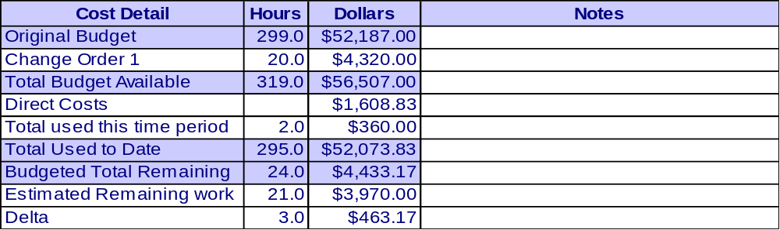
Note: Invoices to date:
Total

Current Risks, Action Items, Issues, Decisions, Changes, Business Process, and Training

Risks
Opened-ID | Risk / Update | Trigger Event to Watch | Probability | Impact | Overall

Action Items
Opened-ID | Action Items / Updates | Owner | Target Date  Status

Issues
Opened-ID | Issues / Updates | Owner | Target Date  Status

Decisions
Date-ID | Decision Log | Owner

Change Log
Date | # | Change Title | Status

Business Process
Date-ID |  | Owner

Training Needs
Date-ID |  | Owner

